CLINICAL  PRACTICE  GUIDELINE | Procedure: | Congestive Heart Failure
 | Guideline Review Cycle: | Biennial
 | Reviewed By: | Amish Purohit, MD, MHA, CPE, FACHE
 | Review Date: | February 2017
 | Committee Approval Date: | 02/27/2017

PURPOSE:
To guide AzPC network providers in the diagnosis and treatment of Congestive Heart Failure. The goal is to prevent hospitalization and re-admission, to clinically improve symptoms, and to achieve best practice in managing CHF patients. This CPG is written based on 2013 American College of Cardiology Foundation/American Heart Association Guidelines. This CPG is not intended to replace a physician’s clinical medical judgment which should be based on current medical knowledge and practices.
DESCRIPTION:
Congestive Heart Failure (CHF) is a complex clinical syndrome that results from any structural or functional impairment of ventricular filling or ejection of blood. The clinical manifestations of CHF are dyspnea, fatigue, and fluid retention. The lifetime risk of developing CHF is 20% for Americans > 40 years of age. There are >650,000 new diagnosed cases annually. CHF is the primary diagnosis in > 1 million hospitalizations annually, with a 1 month readmission rate of 25%. The total cost of heart failure in the United States exceeds $30 billion annually, with over half the costs spent on hospitalizations. Important risk factors are hypertension, diabetes mellitus, metabolic syndrome, and atherosclerotic disease.
RECOMMENDATIONS TO PCP’s:
- Arizona Priority Care recommends the adoption of the American College of Cardiology/American Heart Association 2013 Guideline Update for the Diagnosis and Management of Chronic Heart Failure in the Adult, Canadian Cardiovascular Society Guidelines, the European Society of America guidelines, and the 2010 National Institute for Health and Care Excellence Chronic HF guideline.
- To control and monitor symptoms and weight and maximum medical intervention.
- High-Risk Team, Hospitalist Team, Primary Care Physician, Case Management/Social Workers and other ancillary services to work together with effective CHF guidelines.
ATTACHMENTS:
- The HF Treatment Algorithm from the American Heart Association and American College of Cardiology 2013
-HFrEF is Heart Failure Reduced Ejection Fraction which is less than or equal to 40%
-HFpEF is Heart Failure with Preserved Ejection Fraction
-GDMT is Goal Directed Medical Treatment
-CHADS2 score: CHF, HTN, Age >/= 75, DM, previous CVA or TIA
-HRQOL is Heart related Quality of Life

GOAL

To provide guidelines for:
- Early and ongoing control of congestive heart failure symptoms through lifestyle management and pharmacotherapy to reduce complications, improve outcomes and life expectancy.
- Preserving the left ventricular myocardium
- Achieving optimal pharmacotherapy with minimal or no side effects
- Minimizing the need for acute services (ER encounters, urgent care, and hospitalizations)

ASSESSMENT AND DIAGNOSIS:

- Complaints of paroxysmal nocturnal dyspnea, orthopnea or new-onset dyspnea on exertion; cough, fatigue, peripheral edema
- Diagnostic testing should include chest X-ray, ECG, CBC, serum electrolytes (including calcium and magnesium), serum creatinine and BUN, serum albumin, liver function tests, fasting lipid profile, fasting glucose, BNP, and urinalysis; serial monitoring of electrolytes and renal function
- Consider screening for hemochromatosis or HIV in select patients if indicated
- Consider testing for amyloidosis or pheochromocytoma if clinical suspicion
- 2D ECHO with Doppler initially, with any clinical change, and after treatment
- Noninvasive imaging and testing to detect myocardial ischemia and viability
- T4 and thyroid-stimulating hormone (TSH) level for patients> 65 years of age, or who have atrial fibrillation or evidence of thyroid disease
- For Stages of CHF, see attachment, excerpted from the report of the American College of Cardiology/American Heart Association Task Force on Practice Guidelines (lACC-Vol. 38, Nov. 7,2001 pages 2102-2103).

RECOMMENDED THERAPIES:

- Routine Outpatient Management, volume status and VS at every encounter
- Daily weight recording/monitoring. Instruct the member when to call the physician for unexplained weight gain of greater than three to five pounds, unless a lower range is prescribed.
- Daily fluid intake monitoring, 1.5-2 L daily with refractory HF, especially patients with hyponatremia
- Low sodium diet, less than 3 grams daily per 2013 ACC/AHA guidelines
- Prescribed exercise program
- Smoking cessation
- Alcohol restriction
- Weight reduction in obese patients, goal to be within 10% of ideal body weight
- Annual influenza vaccine
- Pneumococcal vaccine (generally once in a lifetime)
- Control HTN and lipid disorders
- Treat Sleep Apnea with CPAP
- Avoid cardiotoxic agents, see attachment
- Cardiac rehabilitation in clinically stable patients with HF

Pharmacologic therapy of Heart Failure and Hypertension, recommended in the following sequence

- Beta blockers initiate once patient on target ACEI/ARB, start low dose and titrate to target dose; complication of fluid overload may occur, manage with diuretics
- Loop diuretics first for fluid control, relief of signs and symptoms of volume overload
- ACE Inhibitors, or if not tolerated, ARBs initiated during or after optimization of diuretic therapy, start at low doses and titrate to goals based on trial data, or angiotensin receptor-neprilysin inhibitor (ARNI)
- Beta blockers can also reduce angina with ischemic heart disease
- For Stage C HF/NYHA II-IV patients, add mineralocorticoid receptor antagonist (MRA) as long as GFR >30 mL/min and serum K+ <5.0 mEq/dL
- These agents improve survival in patients with HFrEF
- Combination of loop diuretics, some vasoselective calcium channel blockers (eg amlodipine and felodipine) hydralazine, and nitrates (particularly African Americans) with reduced LVEF who have persistent symptoms, NYHA class III-IV, despite therapy with ACEI and beta-blocker or who cannot tolerate ACEI, ARB, or ARNI and an MRA(if indicated)
- For Stage D HF, until definitive therapy or resolution of the acute precipitating problem, patients with cardiogenic shock should receive temporary IV inotropic support to maintain systemic perfusion and preserve end-organ performance. Also, evaluate for cardiac transplantation or Mechanical Circulatory Support (ex. VADs), and palliative care
- Consider also continuous IV inotropic support as palliative therapy for symptom control in Stage D HF
- Chronic Anticoagulation if atrial fibrillation present, CHADS2 scoring
- Omega-3 polyunsaturated fatty acid (PUFA) supplementation is reasonable as adjunctive therapy unless contraindicated to reduce mortality and cardiovascular hospitalizations
- See attachment, Stages, Phenotypes, and Treatment of HF from ACC/AHA
- Digoxin may be beneficial in HFrEF; patients with HFrEF who continue to have NYHA functional class II, III, and IV symptoms despite appropriate therapy including an ACE inhibitor, beta blocker, an aldosterone antagonist if indicated, and an additional diuretic if necessary for fluid control
- See attachment , Drugs Commonly Used for HFrEF (Stage C HF) from ACC/AHA for drugs and doses used in HF treatment

Hospital Management
- May be indicated if the following findings are present:
- Clinical or electrocardiographic evidence of acute myocardial ischemia
- Pulmonary edema or severe respiratory distress
- Oxygen saturation below 90% (not due to pulmonary disease)
- Severe complicating medical illness (e.g., pneumonia)
- Anasarca
- Symptomatic hypotension or syncope
- Persistent NYHA Class 3 or 4 despite maximal outpatient therapy
- Post hospital patient contact should be within one week following discharge to ensure patient understanding and compliance with treatment plan.

PATIENT EDUCATION

General Counseling
- Explanation of heart failure and the reason for symptoms
- Cause or probable cause of heart failure
- Expected symptoms
- Symptoms of worsening heart failure and what to do if they occur
- Self-monitoring of daily weights and when to call physician
- Explanation of treatment/plan of care
- Clarification of patient's responsibilities
- Importance of cessation of tobacco use
- Role of family members or other caregivers in the treatment/plan of care
- Availability and value of qualified local support group
- Importance of obtaining vaccinations against influenza and pneumococcal disease
- Importance of compliance with treatment/plan of care
- Medication counseling: likely side effects, importance of compliance
- Dietary recommendations, including sodium, fluid, and alcohol restriction
- Activity recommendations, including cardiac rehabilitation if indicated and discussion of sexual activity

Prognosis
- Life expectancy
- Advance directives
- Advice for family members in the event of sudden death

SPECIALIST INVOLVEMENT
- Cardiology referral for complete cardiac evaluation and continued follow up
- Consider Palliative Care if end stage CHF, elderly with multiple comorbidities with no meaningful improvements in survival with aggressive therapy
- Electrophysiologist or cardiothoracic surgeon if indicated by cardiology evaluation and recommendations
- Complex Care Physician for additional support in managing CHF patients

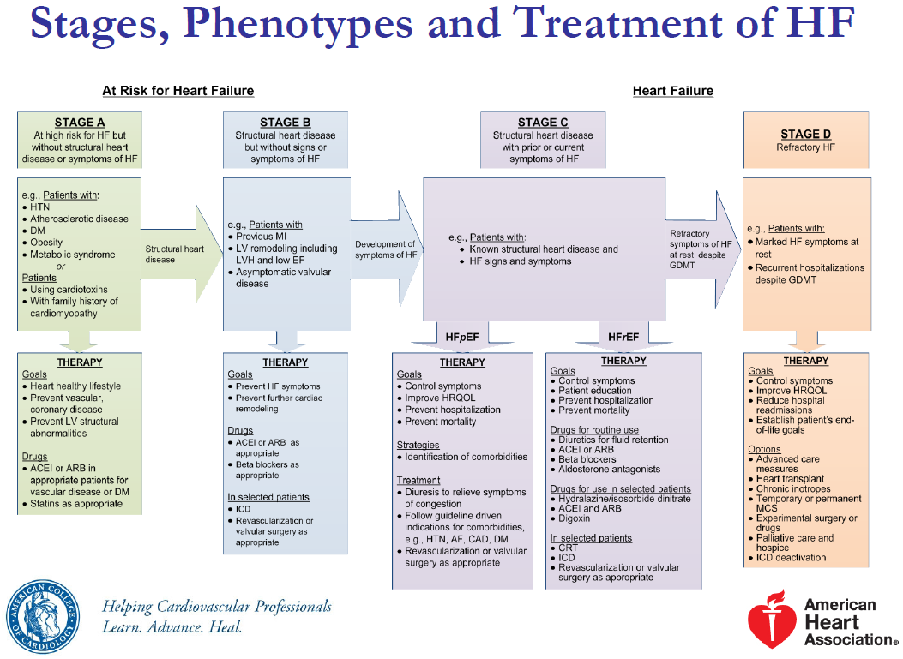

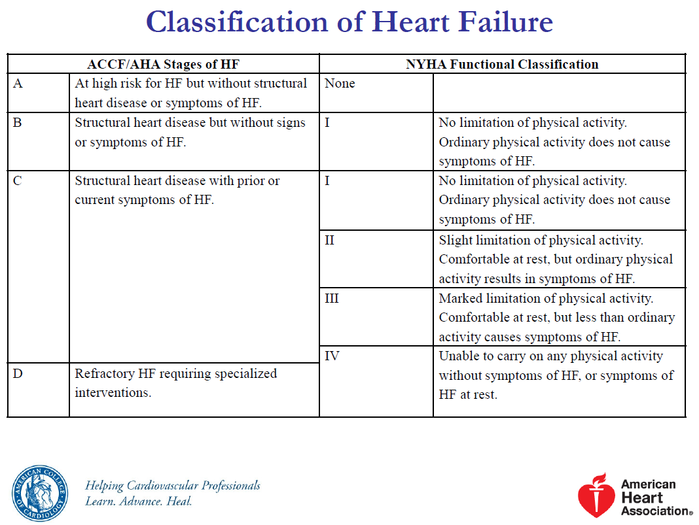

©2017 UpToDate®
Recommendations for pharmacological therapy for management of stage C HFrEF

ACE: angiotensin-converting enzyme; AF: atrial fibrillation; ARB: angiotensin-receptor blocker; COR: Class of Recommendation; DM: diabetes mellitus; GDMT: guideline-directed medical therapy; HF: heart failure; HFpEF: heart failure with preserved ejection fraction; HFrEF: heart failure with reduced ejection fraction; LOE: Level of Evidence; LVEF: left ventricular ejection fraction; MI: myocardial infarction; N/A: not available; NYHA: New York Heart Association; PUFA: polyunsaturated fatty acids.
* In the absence of contraindications to anticoagulation.
Original figure modified for this publication. Yancy CW, Jessup M, Bozkurt B, et al. 2013 ACCF/AHA guideline for the management of heart failure: a report of the American College of Cardiology Foundation/American Heart Association Task Force on Practice Guidelines. J Am Coll Cardiol 2013; 62:e147. Table used with the permission of Elsevier Inc. All rights reserved.
Graphic 91786 Version 2.0

