CLINICAL  PRACTICE  GUIDELINE | Procedure: | Diabetes
 | Guideline Review Cycle: | Biennial
 | Reviewed By: | Amish Purohit, MD, MHA, CPE, FACHE
 | Review Date: | February 2017
 | Committee Approval Date: | 02/27/2017
PURPOSE
To guide AzPC network physicians in the diagnosis and treatment of Diabetes. To prevent complications of diabetes and to achieve best practice in managing diabetes. This Clinical Practice Guideline is not intended to replace a physician’s clinical medical judgment which should be based on current medical knowledge and practices.

Description
Diabetes is a complex, chronic illness that requires continuing medical care and patient self-management education to prevent acute complications and to reduce the risk of long-term complications. Diabetes care requires that many issues, beyond glycemic control, be addressed. A large body of evidence exists that supports a range of interventions to improve diabetes outcomes. These standards of care are intended to provide clinicians, with the components of diabetes care, treatment goals, and tools to evaluate the quality of care.

RECOMMENDATIONS TO PROVIDERS
- Adopt the recommendations set forth in the American Diabetes Association Clinical Practice Recommendation titled Standards of Medical Care in Diabetes – 2017
- Follow practice guidelines to maximize diabetic care, improve patient outcomes and minimize diabetic complications
- Understand that for optimal outcomes an individualized diabetic care plan must be developed for each patient
- Implement a treatment plan that is patient-centered
- Be aware of the psychosocial determinant of health that effect a patient’s ability to achieve optimal goals

ATTACHMENTS
American Diabetes Association Clinical Practice Recommendation titled Standards of Medical Care in Diabetes – 2017 which was published in the Journal of Clinical and Applied Research and Education volume 40, Supplement I, Jan 2017, Figure 8.1 and 8.2

FIGURE 8.1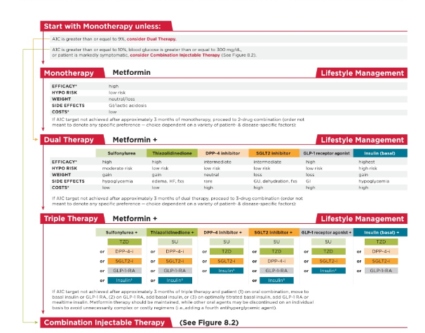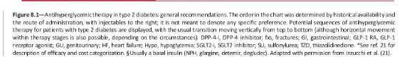

FIGURE 8.2
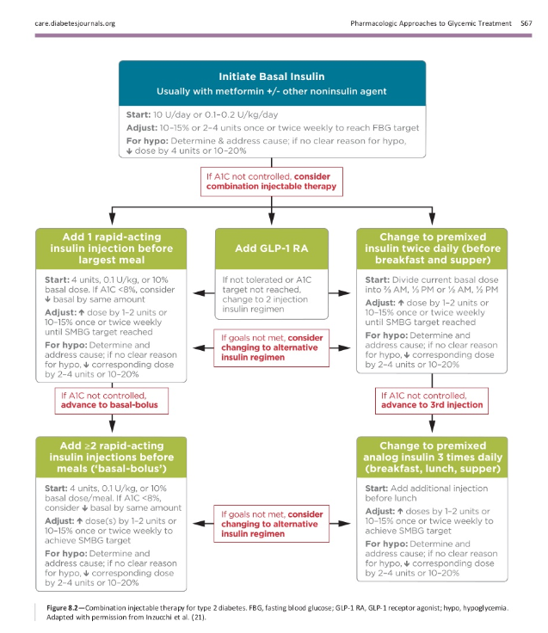

GOALS
To provide guidelines for:
- Screening for DM type II
- Diagnosing DM type II
- Evaluating and assessing the diabetic patient
- Preventing acute complications and chronic end organ complications
- Maximizing glycemic control
- Managing cardiovascular disease

CRITERIA FOR TESTING FOR DIABETES OR PREDIABETES IN ASYMPTOMATIC ADULTS
- Testing should be considered in overweight or obese ( BMI ≥25 or ≥ 23 in Asian Americans) adults who have one or more of the following risk factors:
  - Pre-diabetes:
  - A1C of 5.7 – 6.4%
  - 2 hour plasma glucose of 140-199 mg/dL during a 75 gram OGTT
  - Fasting plasma glucose of 100-125 mg/dL
  - first degree relative with DM
  - high risk race/ethnicity (e.g., African American, Latino, Native American, Asian American, Pacific Islander)
  - women who were diagnosed with gestational diabetes
  - history of CVD
  - hypertension (≥ 140/90 or on therapy for hypertension)
  - HDL cholesterol level < 35 mg/dL and /or a triglyceride level of > 250 mg/dL
  - women with polycystic ovary syndrome
  - physical inactivity
  - other clinical conditions associated with insulin resistance (e.g., severe obesity, acanthosis nigricans)
- All adults 45 years and older should be tested regardless of weight
- If results are normal, testing should be repeated at minimum of 3-year intervals, with consideration of more frequent testing depending on initial results (e.g., those with prediabetes should be tested yearly and risk status

CRITERIA FOR THE DIAGNOSIS OF DIABETES
- Any one of the following three parameters on two separate days confirms the diagnosis of diagnosis of diabetes:
  - A1Cs ≥ 6.5%
  - FPG ≥ 126 (fasting defined as no caloric intake for at least 8 hours)
  - 2-h PG ≥ 200 mg/dL during an OGTT (use a glucose laod containing the equivalent of 75 g anhydrous glucose dissolved in water)
  - Symptoms + random glucose ≥ 200
- In a patient with classic symptoms of hyperglycemia or hyperglycemic crisis, a random plasma glucose ≥ 200 mg/dL meets criteria for diagnosing diabetes (no confirmatory test needed)

COMPREHENSIVE MEDICAL EVALUATION AND ASSESSMENT
- Inquire and educate about acute complications of diabetes such as hypoglycemia awareness, frequency and causes
- Review comorbid conditions including but not limited to dental health, hypertension, dyslipidemia and obesity
- Examine for micro and macro vascular complications such as: retinopathy, nephropathy, neuropathy, coronary heart disease, cerebrovascular disease, and peripheral arterial disease
- Assess psychosocial barriers that will impact a patient’s ability to successfully manage diabetes, follow a medication and nutritional plan such as: finances, resources, nutritional knowledge and social support
- Screen for depression, anxiety, drug or alcohol abuse, physical activity
- Order appropriate tests such as: diabetic retinal eye exam, renal function, hemoglobin a1c, liver function, fasting lipids
- Assess medication adherence, develop a nutritional plan, manage obesity and reinforce understanding of self-management tools
- Provide routine vaccinations
- Review labs, patient’s home glucose monitoring, blood pressure and BMI
- Examine patient for evidence of end organ damage including a diabetic foot exam and examine skin at site of insulin injections if needed
- Discuss glycemic targets

PHARMACOLOGIC THERAPY
Glycemic control
Goal: < 7%
Consider a less stringent goal such as <8 for those with a history of severe hypoglycemia, limited life expectancy, advanced microvascular or macrovascular complications or extensive comorbid conditions.
Consider a more stringent A1C goal of <6.5% for patients with short duration of diabetes, treatment with lifestyle or metformin only, long life expectancy or no significant cardiovascular disease

- A patient-centered, individualized plan should be developed taking into consideration efficacy, hypoglycemic risk, impact on weight, potential side effects, cost and patient preference
- Lifestyle modifications should be encouraged and supported
- If not contraindicated, Metformin is preferred initial pharmacological agent
- If Metformin is contraindicated or not tolerated then start a drug from another class such as: sulfonylurea, thiazolidinedione, DPP-4 inhibitor, SGLT2 inhibitor, GLP-1 receptor agonist or insulin
- If A1C target is not met after 3 months with maximal tolerated dose, then add a second agent
- If A1c target not met on dual therapy start a third agent
- If patient does not meet glycemic control insulin therapy should not be delayed
- If a patients A1C is ≥ 9% consider staring with dual therapy
- If patient is newly diagnosed and is symptomatic and /or has an A1C ≥ 10% and/or has a glucose level ≥ 300 consider starting with insulin therapy

Blood pressure control
Goal: <140/90 or 130/80 for patients at high risk for cardiovascular disease:

- Life style modification should be implemented
- Consider administering at least one antihypertensive medication at bedtime
- If tolerated ACE inhibitors or ARBs at maximum tolerated doses are fist-line therapy for patients with hypertension and albuminuria
- In patients without albuminuria and cardiovascular disease prevention is the primary goal then a thiazide-like diuretic or dihydropyridine calcium channel blocker may be consider instead of or in addition to an ACE-I or ARB
- If blood pressure goals are not met additional drug therapy should be initiated

Lipid management
- Life-style modifications
- High-intensity statin therapy should be added to life-style modifications for diabetic patients with atherosclerotic cardiovascular disease
- May consider moderate-intensity statin therapy in patients
  - < 40 years old with ASCVD risk factors * (if no ASCVD risk factors then no statin therapy is recommended)
  - 40-75 years old with no ASCVD risk factors
  - > 75 with or without ASCVD risk factors
*ASCVD risk factors include: LDL ≥ 100 mg/dL, high blood pressure, smoking, chronic kidney disease, albuminuria, and family history of premature ASCVD
- Adjust medication therapy based on patient tolerance
- May use moderate intensity statin with ezetimibe in patients with ASCVD who cannot tolerate high dose statins

Antiplatelet agents
- Use aspirin therapy (75-162 mg/day) for secondary prevention in patients with ASCVD
- If aspirin therapy is not tolerated use clopidogrel 75 mg/day
- Consider duel therapy for a year after an acute coronary syndrome
- Consider aspirin therapy for primary prevention in patients at increased cardiovascular risk (≥ 50 years and one additional major risk factor )
- Aspirin is not recommended for primary prevention for adults with low cardiovascular disease risk (<50 years with no ACVD risk factors)
- Use clinical judgement when considering aspirin therapy in patients <50 with multiple other ASCVD risk factors

PATIENT INSTRUCTIONS
- Develop a diabetic care plan with your physician
- Engage in life-style modification and risk factor management
- Self-monitor blood glucose
- Adhere to medication regime
- Comply with preventative screenings such foot care and diabetic retinal exam

SPECIAL INVOLVEMENT
- Specialist involvement may be indicated when the following are present:

  - Any hospital admission for diabetes or acute metabolic complications
  - Evidence of target organ disease
  - Persistent elevation of HbA1c
  - Pre-conception for females during child bearing years and post-conception
  - Consideration and management of an insulin pump

